**Acropolis Institute Of Technology And Research,**

**Indore (M.P.)**



**Subject – Database Management System (DBMS)**

**(CY-405)**

**Name – Harshit Nagar**

**Enrollment No. – 0827EC221022**

**Branch - CS(Cyber Security)**

**Semester - 4th  (2nd year)**

**Submitted To – Submitted by –**

**Prof. Nidhi Nigam Harshit Nagar**

**Index**

|  |  |  |  |  |
| --- | --- | --- | --- | --- |
| **Sr. No.** | **Experiment** | **Date of Exp.** | **Date of sub.** | **Grade** |
| 1. | To study DBMS and RDBMS, its characteristic comparisons and study of popular DB software. | 11/03/24 | 18/03/24 |  |
| 2. | Study of MySQL, Features of MySQL, Installation steps. | 18/4/24 | 1/4/2024 |  |
|  |  |  |  |  |
|  |  |  |  |  |
|  |  |  |  |  |
|  |  |  |  |  |
|  |  |  |  |  |
|  |  |  |  |  |
|  |  |  |  |  |
|  |  |  |  |  |
|  |  |  |  |  |
|  |  |  |  |  |

* **LAB WORK 2**

Study of MySQL, Features of MySQL, Installation steps.

**MY SQL :**

MySQL  is an [open-source](https://en.wikipedia.org/wiki/Open-source_software) [relational database management system](https://en.wikipedia.org/wiki/Relational_database_management_system) (RDBMS).[[5]](https://en.wikipedia.org/wiki/MySQL#cite_note-whatismysql-5)[[6]](https://en.wikipedia.org/wiki/MySQL#cite_note-6) Its name is a combination of "My", the name of co-founder daughter My,[[7]](https://en.wikipedia.org/wiki/MySQL#cite_note-7) and "SQL", the acronym for [Structured Query Language](https://en.wikipedia.org/wiki/Structured_Query_Language). A [relational database](https://en.wikipedia.org/wiki/Relational_database) organizes data into one or more data tables in which data may be related to each other; these relations help structure the data. SQL is a language that programmers use to create, modify and extract data from the relational database, as well as control user access to the database. In addition to relational databases and SQL, an RDBMS like MySQL works with an [operating system](https://en.wikipedia.org/wiki/Operating_system) to implement a relational database in a computer's storage system, manages users, allows for network access and facilitates testing database integrity and creation of backups.

MySQL is [free and open-source software](https://en.wikipedia.org/wiki/Free_and_open-source_software) under the terms of the [GNU General Public License](https://en.wikipedia.org/wiki/GNU_General_Public_License), and is also available under a variety of [proprietary](https://en.wikipedia.org/wiki/Proprietary_software) licenses. MySQL was owned and sponsored by the [Swedish](https://en.wikipedia.org/wiki/Sweden) company [MySQL AB](https://en.wikipedia.org/wiki/MySQL_AB), which was bought by [Sun Microsystems](https://en.wikipedia.org/wiki/Sun_Microsystems) (now [Oracle Corporation](https://en.wikipedia.org/wiki/Oracle_Corporation)).[[8]](https://en.wikipedia.org/wiki/MySQL#cite_note-sunacquire-8) In 2010, when [Oracle acquired Sun](https://en.wikipedia.org/wiki/Acquisition_of_Sun_Microsystems_by_Oracle_Corporation), Widenius [forked](https://en.wikipedia.org/wiki/Fork_(software_development)) the [open-source](https://en.wikipedia.org/wiki/Open-source) MySQL project to create [MariaDB](https://en.wikipedia.org/wiki/MariaDB" \o "MariaDB).[[9]](https://en.wikipedia.org/wiki/MySQL#cite_note-9)

MySQL has stand-alone clients that allow users to interact directly with a MySQL database using SQL, but more often, MySQL is used with other programs to implement applications that need relational database capability. MySQL is a component of the [LAMP](https://en.wikipedia.org/wiki/LAMP_(software_bundle)) [web application](https://en.wikipedia.org/wiki/Web_application) [software stack](https://en.wikipedia.org/wiki/Software_stack) (and [others](https://en.wikipedia.org/wiki/List_of_AMP_packages)), which is an acronym for [Linux](https://en.wikipedia.org/wiki/Linux), [Apache](https://en.wikipedia.org/wiki/Apache_HTTP_Server), MySQL, [Perl](https://en.wikipedia.org/wiki/Perl)/[PHP](https://en.wikipedia.org/wiki/PHP)/[Python](https://en.wikipedia.org/wiki/Python_(programming_language)). MySQL is used by many database-driven web applications, including [Drupal](https://en.wikipedia.org/wiki/Drupal), [Joomla](https://en.wikipedia.org/wiki/Joomla), and [WordPress](https://en.wikipedia.org/wiki/WordPress).[[10]](https://en.wikipedia.org/wiki/MySQL#cite_note-10) MySQL is also used by many popular [websites](https://en.wikipedia.org/wiki/Website), including [Facebook](https://en.wikipedia.org/wiki/Facebook),[[11]](https://en.wikipedia.org/wiki/MySQL#cite_note-11)[[12]](https://en.wikipedia.org/wiki/MySQL#cite_note-12) [Flickr](https://en.wikipedia.org/wiki/Flickr),[[13]](https://en.wikipedia.org/wiki/MySQL#cite_note-13) [MediaWiki](https://en.wikipedia.org/wiki/MediaWiki),[[14]](https://en.wikipedia.org/wiki/MySQL#cite_note-14) [Twitter](https://en.wikipedia.org/wiki/Twitter),[[15]](https://en.wikipedia.org/wiki/MySQL#cite_note-15) and [YouTube](https://en.wikipedia.org/wiki/YouTube).[[16]](https://en.wikipedia.org/wiki/MySQL#cite_note-16).

SS of default my sql command:

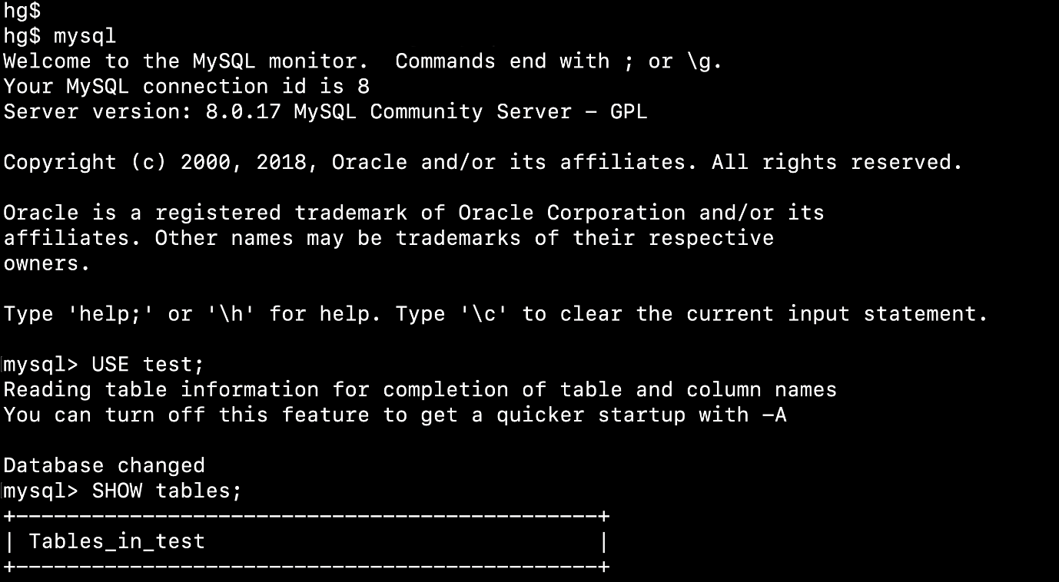

STUDY OF MYSQL :

How MySQL Works?

MySQL follows the working of Client-Server Architecture. This model is designed for the end-users called clients to access the resources from a central computer known as a server using network services. Here, the clients make requests through a graphical user interface (GUI), and the server will give the desired output as soon as the instructions are matched. The process of MySQL environment is the same as the client-server model.

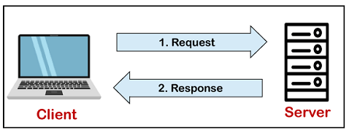

The core of the MySQL database is the MySQL Server. This server is available as a separate program and responsible for handling all the database instructions, statements, or commands. The working of MySQL database with MySQL Server are as follows:

1. MySQL creates a database that allows you to build many tables to store and manipulate data and defining the relationship between each table.
2. Clients make requests through the GUI screen or command prompt by using specific SQL expressions on MySQL.
3. Finally, the server application will respond with the requested expressions and produce the desired result on the client-side.

A client can use any MySQL [GUI](https://www.javatpoint.com/gui-full-form). But, it is making sure that your GUI should be lighter and user-friendly to make your data management activities faster and easier. Some of the most widely used MySQL GUIs are MySQL Workbench, SequelPro, DBVisualizer, and the Navicat DB Admin Tool. Some GUIs are commercial, while some are free with limited functionality, and some are only compatible with MacOS. Thus, you can choose the GUI according to your needs.

# **MySQL Features**

MySQL is a relational database management system (RDBMS) based on the SQL (Structured Query Language) queries. It is one of the most popular languages for accessing and managing the records in the table. MySQL is open-source and free software under the GNU license. Oracle Company supports it.

The following are the most important features of MySQL:

**Relational Database Management System (RDBMS)**

[MySQL](https://www.javatpoint.com/mysql-tutorial) is a relational database management system. This database language is based on the [SQL](https://www.javatpoint.com/sql-tutorial) queries to access and manage the records of the table.

**Easy to use**

MySQL is easy to use. We have to get only the basic knowledge of SQL. We can build and interact with MySQL by using only a few simple SQL statements.

**It is secure**

MySQL consists of a solid data security layer that protects sensitive data from intruders. Also, passwords are encrypted in MySQL.

**Client/ Server Architecture**

MySQL follows the working of a client/server architecture. There is a database server (MySQL) and arbitrarily many clients (application programs), which communicate with the server; that is, they can query data, save changes, etc.

**Free to download**

MySQL is free to use so that we can download it from MySQL official website without any cost.

**It is scalable**

MySQL supports multi-threading that makes it easily scalable. It can handle almost any amount of data, up to as much as 50 million rows or more. The default file size limit is about 4 GB. However, we can increase this number to a theoretical limit of 8 TB of data.

**Speed**

MySQL is considered one of the very fast database languages, backed by a large number of the benchmark test.

**High Flexibility**

MySQL supports a large number of embedded applications, which makes MySQL very flexible.

**Compatible on many operating systems**

MySQL is compatible to run on many operating systems, like Novell NetWare, Windows* Linux*, many varieties of UNIX* (such as Sun* Solaris*, AIX, and DEC* UNIX), OS/2, FreeBSD*, and others. MySQL also provides a facility that the clients can run on the same computer as the server or on another computer (communication via a local network or the Internet).

**Allows roll-back**

MySQL allows transactions to be rolled back, commit, and crash recovery.

**Memory efficiency**

Its efficiency is high because it has a very low memory leakage problem.

**High Performance**

MySQL is faster, more reliable, and cheaper because of its unique storage engine architecture. It provides very high-performance results in comparison to other databases without losing an essential functionality of the software. It has fast loading utilities because of the different cache memory.

**High Productivity**

MySQL uses Triggers, Stored procedures, and views that allow the developer to give higher productivity.

**Platform Independent**

It can download, install, and execute on most of the available operating systems.

**Partitioning**

This feature improves the performance and provides fast management of the large database.

**GUI Support**

MySQL provides a unified visual database graphical user interface tool named "**MySQL Workbench**" to work with database architects, developers, and Database Administrators. [MySQL Workbench](https://www.javatpoint.com/mysql-workbench) provides SQL development, data modeling, data migration, and comprehensive administration tools for server configuration, user administration, backup, and many more. MySQL has a fully GUI supports from MySQL Server version 5.6 and higher.

**Dual Password Support**

MySQL version 8.0 provides support for dual passwords: one is the current password, and another is a secondary password, which allows us to transition to the new password.

### **Disadvantages/Drawback of MySQL**

Following are the few disadvantages of MySQL:

* MySQL version less than 5.0 doesn't support ROLE, COMMIT, and stored procedure.
* MySQL does not support a very large database size as efficiently.
* MySQL doesn't handle transactions very efficiently, and it is prone to data corruption.
* MySQL is accused that it doesn't have a good developing and debugging tool compared to paid databases.
* MySQL doesn't support SQL check constraints.

# **MySQL Installation on Windows:**

Here we will show you step by step how to install MySQL on the Windows platform using the MySQL Installer.

## Download MySQL

The simplest and recommended method is to download MySQL Installer for Windows from <https://dev.mysql.com/downloads/installer/> and execute it.

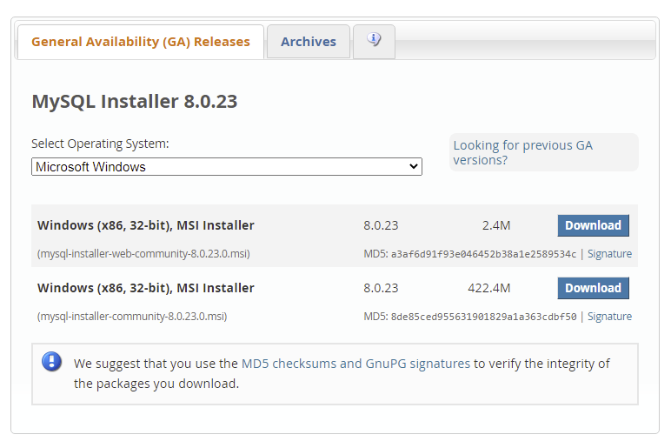

Select mysql-installer-web-community-8.0.23.msi if you have good internet connection, otherwise choose mysql-installer-community-8.0.23.msi.

## Install MySQL

After downloading, unzip it, and double click the MSI installer .exe file.

Then follow the steps below:

1. **"Choosing a Setup Type"** screen: Choose "Full" setup type. This installs all MySQL products and features. Then click the "Next" button to continue.

2. **"Check Requirements"** screen: The installer checks if your pc has the requirements needed. If there is some failing requirements, click on each item to try to resolve them by clicking on the Execute button that will install all requirements automatically. Click "Next".

3. **"Installation"** screen: See what products that will be installed. Click "Execute" to download and install the Products. After finishing the installation, click "Next".

4. **"Product Configuration"** screen: See what products that will be configured. Click the "MySQL Server 8.0.23" option to configure the MySQL Server. Click the "Next" button. Choose the "Standalone MySQL Server/Classic MySQL Replication" option and click on the "Next" button. In page  "Type and Networking" set Config Type to "Development Computer" and "Connectivity" to "TCP/IP" and "Port" to "3006". Then, click the "Next" button.

5. **"Authentication Method"** screen: Choose "Use Strong Password Encryption for Authentication". Click "Next".

6. **"Accounts and Roles"** screen: Set a password for the root account. Click "Next".

7. **"Windows Service"** screen: Here, you configure the Windows Service to start the server. Keep the default setup, then click "Next".

8. **"Apply Configuration"** screen: Click the "Execute" button to apply the Server configuration. After finishing, click the "Finish" button.

9. **"Product Configuration"** screen: See that the Product Configuration is completed. Keep the default setting and click on the "Next" and "Finish" button to complete the MySQL package installation.

10. In the next screen, you can choose to configure the Router. Click on "Next", "Finish" and then click the "Next" button.

11. **"Connect To Server"** screen: Type in the root password (from step 6). Click the "Check" button to check if the connection is successful or not. Click on the "Next" button.

12. **"Apply Configuration"** screen: Select the options and click the "Execute" button. After finishing, click the "Finish" button.

13. **"Installation Complete"** screen: The installation is complete. Click the "Finish" button.

## Verify MySQL Installation

Open the **MySQL Command Line Client** from cmd.

You should see a mysql> prompt. If you have set any password, write your password here.

Now, you are connected to the MySQL server, and you can execute all the SQL command at mysql> prompt as follows:

For example: Check the already created databases with show databases command: